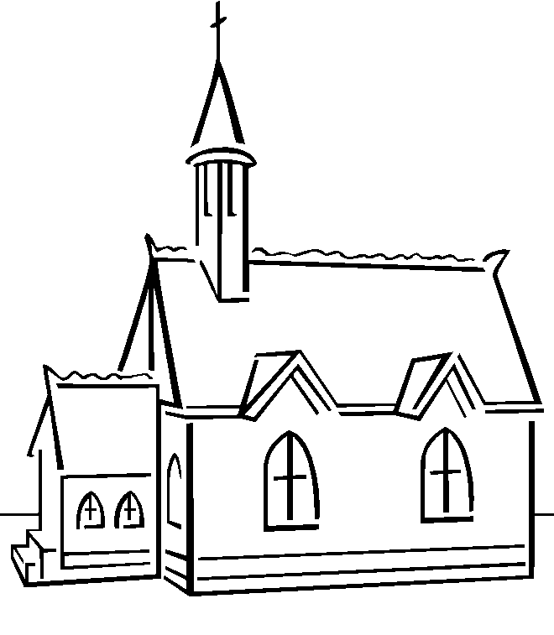
_ _ _ _ _ _ _ _ the _ _ _ _ _ _ _ day by keeping it holy.
Exodus 20:8_{NLT}

